#### F.5 Biology (2021-2022) Reproduction in Human

**Name:_____________________________ ( ) F.5 ______ Date: _____________**

**Staions 1 and 2: Male and female reproductive system.**

(i) Identify the labelled structure in the model:

|  |  |  |  |  |
| --- | --- | --- | --- | --- |
| (1). Male reproductive system | |  | (2.i). Female reproductive system | |
| A | **testis** |  | P | **ovary** |
| B | **epididymis** |  | Q | **oviduct** |
| C | **Sperm duct** |  | R | **uterus** |
| D | **Prostate gland** |  | S | **cervix** |
| E | **Cowper’s gland** |  | T | **vagina** |
| F | **Seminal vesicle** |  |  |  |
| G | **urethra** |  |  |  |
| H | **Urinary bladder** |  |  |  |

(2.ii.) Examine the prepared slides under the microscopes, write down two structures you can identify in each of them.

|  |
| --- |
| **Testis: seminiferous tubules** |
| **Ovary: follicles** |

**Station 3: Embryonic development**

1. Name process L: _**fertilization**_______________________________________________
2. Name process M:_**mitotic cell division__**______________________________________
3. Write down the fates of the cells coloured

yellow: __**embryo_____________**___________________________________________

blue: __**placental villi, amnion**______________________________________________

1. Name structure N:__**villus**___________________________________________________

Their presence can **increase the surface area for the exchange of materials between the maternal and foetal blood.**

1. Cavity O is filled with a fluid called __**amniotic fluid**__________________________________

Its functions:

|  |
| --- |
| **As shock absorber / protects the embryo from damage due to vibrations.** |
| **Prevents the embryo from drying up.** |
| **Allows the embryo to move easily as it grows.** |
| **Provide a steady environment for the embryo to develop.** |

**Station 4: foetal development**

(i) Identify the labelled structure in the model showing the 7th month of pregnancy and complete the table:

(you need to remove the foetus to expose the structures)

|  |  |  |
| --- | --- | --- |
| **Label** | **Structure** | **Function** |
| X | **amnion** | **Secrete amniotic fluid** |
| Y | **Umbilical cord** | **Contains the umbilical arteries and umbilical vein transports materials between the placenta and foetus** |
| Z | **placenta** | **For exchange of materials between the placenta and foetus** |

(ii) Which structure contains both maternal and foetal tissues? __**placenta________**__________________

(iii) Write down a change observed during the developmental process.

|  |
| --- |
| **The foetus / umbilical cord / placenta/ uterus increases in size.** |
|  |

**Station 5: Rhythm method**

1. Complete the following table:

|  |  |  |  |
| --- | --- | --- | --- |
| **Rhythm method** | | | |
| **Biological basis** | **Failure rate (%)** | **Possible side effects** | **Any limitation?** |
| Preventing sperms from meeting the **ovum** by avoiding sexual intercourse during  the **fertile** period, i.e. the period of the menstrual cycle when **ovulation** is likely to occur. | **25** | **none** | **Very unreliable for women with irregular menstral cycle** |

1. How could we estimate the timing of ovulation?

***Method one:***

|  |
| --- |
| **By recording changes in basal body temp.** |
| **As a sudden rise in basal body temp indicates that ovulation is about to occur.** |

***Method two:***

Some kit available in the market can detect the date of ovulation by detecting a sudden release of a hormone (luteinizing hormone) that triggers ovulation.

1. Mark down on the following graph when should sexual intercourse be carried out to (i) avoid and (ii) ensure pregnancy using pen of different colours.

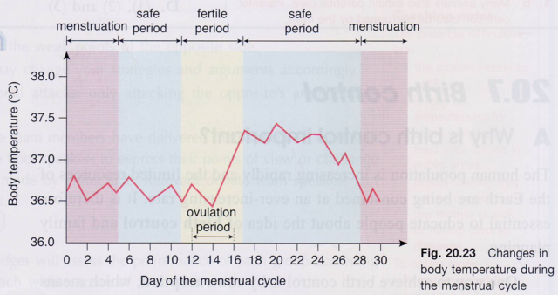

**ii**

i

i

**Station 6: Barrier methods**

1. Complete the following table:

|  |  |  |  |
| --- | --- | --- | --- |
| **Barrier methods** | | | |
| **Biological basis** | **Failure rate (%)** | **Possible side effects** | **Give protection against STDs?** |
| **1. Condom**  Preventing sperms from meeting  the **ovum**  by preventing sperms from entering the **vagina**  . | **15** | **User may be allergic to latex, lubricants or spermicides.** | **Yes.** |
| **2. Diaphragm (with spermicides)**  Preventing sperms from meeting  the **ovum** by preventing sperms from entering the **uterus**  . | **12** | **User may be allergic to latex, lubricants or spermicides.** | **No.** |

(ii) Why should the diaphragm be removed at least 6 hours after the sexual intercourse?

|  |  |
| --- | --- |
| **Sperms could remain survive/ active for some time.** |  |
| **early removal may allow active sperms to enter the uterus.** |  |

**Station 6: Chemical methods**

(i)Complete the following table:

|  |  |  |  |
| --- | --- | --- | --- |
| **Chemical methods** | | | |
| **Biological basis** | **Failure rate (%)** | **Possible side effects** | **Give protection against STDs*?** |
| **1. Spermicides**  Contain chemicals that kill or inactivating **sperms** . | **26** | **User may be allergic to spermicides** | **No.** |
| **2. Contraceptive pills**  Contain high dose of female sex hormones, **oestrogen** and **progesterone**., that inhibit the release of another hormone (LH) which responsible for triggering ovulation. This prevents ovulation, no **ovum** . will be released from ovaries. | **0** | **May cause nausea, headaches, water retention, weight gain and high blood pressure in some women** | **No.** |

1. Study the instruction sheet for the male/female condoms and diaphragm provided and answer the following questions.

How could spermicide (sperm-killing cream) be used with the male/female condoms and diaphragm?

|  |  |
| --- | --- |
| **Spermicide should be applied to surfaces of condoms/diaphragm for** |  |
| **inactivating/killing sperms** |  |

**Station 7: Prevention of implantation**

(i) Complete the following table:

|  |  |  |  |
| --- | --- | --- | --- |
| **Method to prevent implantation (a reversible/irreversible* methods)** | | | |
| **Biological basis** |  | **Possible side effects**  **/ points to note** | **Give protection against STDs**?** |
| 1. **Intra-uterine device (IUD)**   Preventing the embryo from **implanting into the uterus** .  (the exact mechanisms is not clearly known yet; may due to the chemical / _physical _changes_____ caused by the embedment of the foreign materials into the **uterus**.) |  | * **Can cause irritation to the uterine lining** * May cause heavier/longer menstrual flow * May cause _**vaginal**_________bleeding. * May cause __**abdominal**_____ pain. * May increase risk of **pelvic inflammation** . (and thus affecting the fertility in future) * Must be performed by _**a doctor**__. * Can serve as emergency method and must be taken within **5 days** .after the unprotected sexual intercourse. | **No** |
| **2. Morning-after pill**  Preventing the _**embryo**___ from **implanting into the uterus**.  Its action is to interfere with normal hormonal signals that govern events between ovulation and implantation. |  | * **may cause nausea, headaches, tender breast and irregular vaginal bleeding** * must be taken within **72** hours after the unprotected sexual intercourse. * Serves as emergency method and is only available on prescription from a doctor. | **No** |

1. The diagrams below show the male and female reproductive structures. Mark down on the diagram the correct positions where the IUD should beoperated.

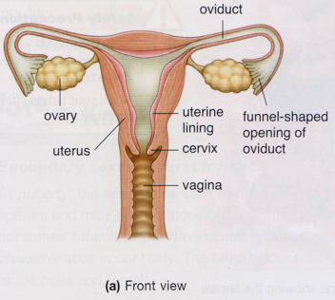

X

**Station 8: Surgical methods (sterilisation)**

1. Complete the following table:

|  |  |  |  |
| --- | --- | --- | --- |
| **Surgical methods (sterilisation) (a reversible/irreversible* methods)** | | | |
| **Biological basis** | **Failure rate (%)** | **Possible side effects** | **Is there production of gametes?** |
| **1. Male sterilisation (**vasectomy)  Preventing sperms from meeting the **egg** . by **cutting** and **tying** the vas deference (i.e. sperm ducts).  **2. Female sterilisation (**tubal ligation**)**  Preventing sperms from meeting the ovum by cutting and tying the **oviducts**.. | **0**  **0** | **irreversible**  (P.S.: the cut ends of the sperm ducts/oviducts may rejoin in some cases, though very rare). | **Yes**  **yes** |

1. Explain why a man’s sexual ability will not be affected after vasectomy.

|  |
| --- |
| Because the development of secondary sexual characteristics is controlled by the male sex |
| hormone which is still produced by the testes and transported in the blood after the |
| operation |

1. Explain whether a woman can have normal menstruation after tubal ligation.

|  |
| --- |
| Yes. |
| As her ovaries continue to produce female sex hormones that are transported in blood and |
| exert effects on the uterine lining to cause menstruation. |

1. The diagrams below show the male and female reproductive structures. Mark down on the diagram the correct positions where the vasectomy and tubal ligation should beoperated.

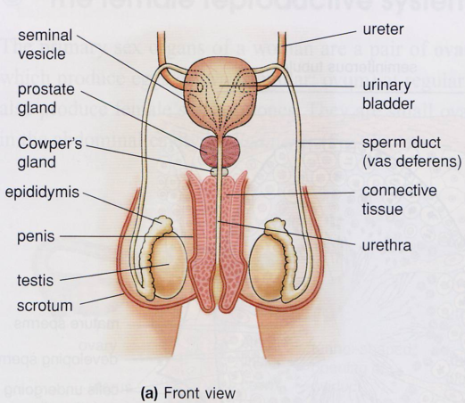



**Study cases of two couples below:**

### Couple 1

We are Mr. and Mrs. Bean. We have just got married and do not plan to have our baby in the coming three to four years due to economic difficulty. We are not sure whether we will want to have our baby later on.

MCj02503890000[1]

**Tick the contraceptive method suggested to the couple:**

|  |  |  |  |
| --- | --- | --- | --- |
| rhythm method | **✔** | diaphragm (with spermicide) | **✔** |
| male condom (with spermicide) | **✔** | contraceptive pills | **✔** |
| female condom (with spermicide) | **✔** | tubal ligation |  |
| IUD |  | vasectomy |  |

### Couple 2

**We are Mr. and Mrs. Peanuts. We have got married for 15 years and already have three sons and one daughter. We do not plan to have more children in the future.**

j0110852

j0395098

**Tick the contraceptive method suggested to the couple:**

|  |  |  |  |
| --- | --- | --- | --- |
| rhythm method |  | diaphragm (with spermicide) | **✔** |
| male condom (with spermicide) | **✔** | contraceptive pills | **✔** |
| female condom (with spermicide) | **✔** | tubal ligation | **✔** |
| IUD | **✔** | vasectomy | **✔** |

Human Reproduction Lab Stations (2021-2022)

|  |  |  |
| --- | --- | --- |
| Station 1 | **Male reproductive system** model | Label A-H, testis, epididymis,  Sperm duct, prostate gland, Cowper’s gland, seminal vesicle, urethra urinary bladder |
| Station 2 | **Female reproductive system** model  **Chart** showing ovarian and menstrual cycle  2 microscopes **slides**:  Slide showing testis  Slide showing ovary | Label P-T: ovary, oviduct, uterus, cervix, vagina |
| Station 3 | **Embryonic development** model | Label process L (fertilization), M (mitotic cell division)  Structure N (villus), Cavity O (amniotic cavity) |
| Station 4 | Models showing **foetal development**  Gastation calculator | Label X (amnion), Y (umbilical cord), Z (placenta) |
| Station 5 | **Rhythm method**  Graph, thermometer |  |
| Station 6 | **Barrier method**  Male condom  Female condom  Diaphragm  Lubricant gel |  |
|  | **Chemical method**  Various kinds of spermicide  Contraceptive pills  Contraceptive injection |  |
| Station 7 | **Prevent implantation**  IUD  Morning after pills |  |
| Station 8 | **Surgical method**  Case studies |  |